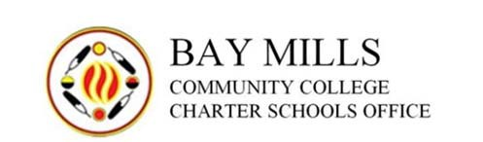

To: All Public School Academies, Boards and Educational Service Providers

From: Bay Mills Community College Charter Schools Office

Re: Authorizer’s Certificate for Short-Term Loans

Dated: May 24, 2022

As a condition to receiving an authorizer’s certificate from the Bay Mills Charter Schools
Office (BMCSO) for any short-term loan or state aid note borrowing, an academy must certify, in writing, to BMCSO that:

• as of the close of the most recent fiscal year, the academy has no outstanding and unpaid management fees;

• the academy has no outstanding and/or unpaid loans, or any other indebtedness that is not disclosed as a permissible debt in its annual financial audit;

• the academy has no hidden or off-book debts, loans of other indebtedness.

By my signature, I acknowledge that I have read, understand and agree to the policies and procedures listed above.

___________________________ _______________
Board President Date

An academy that fails to provide the written certification above, or that fails to disclose all non-compliance with the above certification provisions, will not receive an authorizer certificate from BMCSO. The academy must provide all written certification to BMCSO at least
30 days prior to the proposed closing of the loan.

