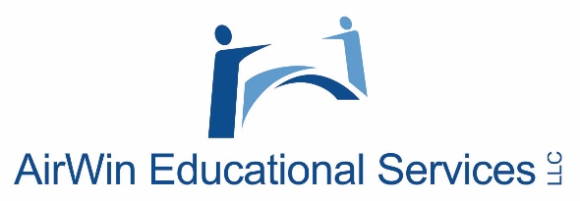

**Creating a Governance Framework**

**Professional Development Regional Session(s)**

**Fall 2024**

**Board Governance (SAMPLE) Topics**

***Over the course of the past several years, AES has had the privilege of hosting several webinars and in-person professional development session/workshops. As you consider creating your governance framework, below is a sample list (not exhaustive) of a few topics we have discussed, historically. Please use these topics as a guide or reminder of the “how” and “planning and relationships” of your framework.***

* Board recruitment
* Board compliance – reporting and transparency
* Decision-making
* Board succession planning
* Managing your finances
* Managing your budget
* Student learning
* Orderly and efficient meetings
* Roles of officers
* Board policy
* Meeting minutes
* Safety and welfare of students
* Parent/community complaints
* Self-assessment
* Management assessment
* Governing over the unexpected
* Suspension and expulsion of students
* Information overload
* The role of the board
* Governance vs. management
* Effective use of committees
* Board culture
* Old and new business
* Communication
* Preparing, reviewing and managing the agenda
* Managing your management relationship
* Assessing board and academy health
* Relationship with school leader, management, each other, etc.
* Governing beyond the school year
* Strategic/future planning
* Three-legged stool