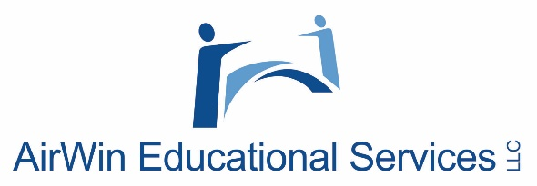

Creating a Governance Framework

Professional Development Regional Session(s)

Fall 2024
Board Governance (SAMPLE) Topics
Over the course of the past several years, AES has had the privilege of hosting several webinars and in-person professional development session/workshops. As you consider creating your governance framework, below is a sample list (not exhaustive) of a few topics we have discussed, historically. Please use these topics as a guide or reminder of the “how” and “planning and relationships” of your framework.
- Board recruitment
- Board compliance – reporting and transparency
- Decision-making
- Board succession planning
- Managing your finances
- Managing your budget
- Student learning
- Orderly and efficient meetings
- Roles of officers
- Board policy
- Meeting minutes
- Safety and welfare of students
- Parent/community complaints
- Self-assessment
- Management assessment
- Governing over the unexpected
- Suspension and expulsion of students
- Information overload
- The role of the board
- Governance vs. management
- Effective use of committees
- Board culture
- Old and new business
- Communication
- Preparing, reviewing and managing the agenda
- Managing your management relationship
- Assessing board and academy health
- Relationship with school leader, management, each other, etc.
- Governing beyond the school year
- Strategic/future planning
- Three-legged stool

